Clothing brand website

Partners: Fatima Yousaf and Aqsa Nazkat

# Purpose

1. Fashion Expression: Provide a platform for individuals to express their unique style
2. 2. Quality and Comfort: Prioritize high-quality materials and comfortable designs.
3. 3. Inclusivity: Embrace diversity in sizing, styles, and models.
4. 4. Sustainability: Incorporate eco-friendly practices and materials.
5. 5. Affordability and Accessibility: Offer a variety of price points to make stylish clothing accessible.
6. 6. Customer Experience: Focus on a seamless online shopping experience.
7. 7. Trendsetting Designs: Stay ahead of fashion trends and provide innovative, unique designs.
8. 8. Community Engagement: Foster a sense of community by engaging customers through social media.
9. 9. Ethical Practices : Ensure ethical sourcing and manufacturing processes.

10.10. Personalization: Integrate personalized shopping experiences, such as style quizzes.

•Targeted Audience

• Online Shoppers

* Diverse Demographics
* Online Shoppers
* Conscious Consumers
* Community-Driven Individuals
* Budget-Conscious
* Shoppers Work and Casual Wear
* Consumers Body Positivity Advocates PROTOTYPE

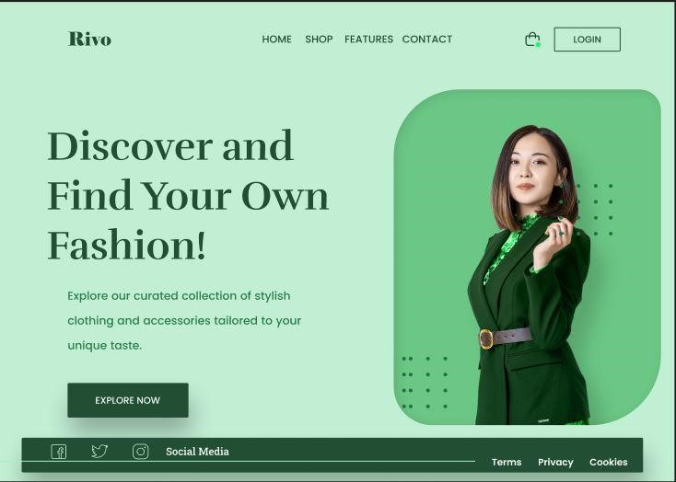

PROTOTYPE

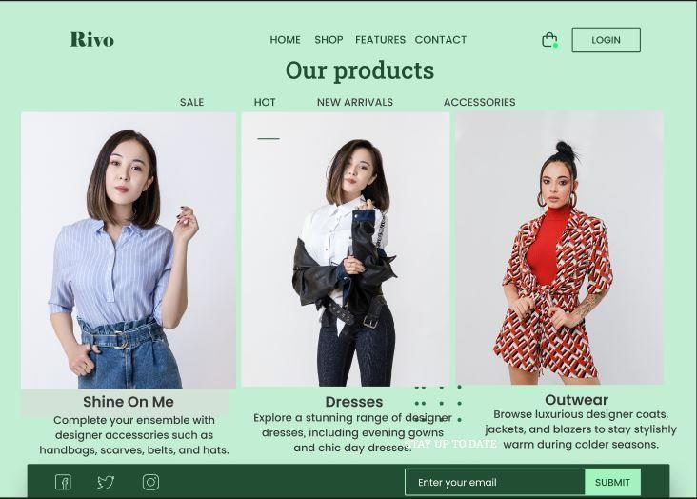

PROTOTYPE

